PRESS RELEASE

Ilorin Innovation Hub joins Afrilabs Network
7 April 2021
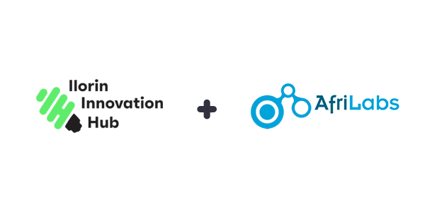
The Ilorin Innovation Hub, which is the first ICT and technology centre established by the Kwara State Government, has joined the Afrilabs Network, the largest network of innovation hubs in Africa. The Ilorin Innovation Hub has two main functions, which are to build technology skills capacity among the young people of Kwara State and to incubate local technology startups. These both go in line with the objectives of Afrilabs, which are to promote the creation of African made technology, capacity building, mentorship, networking and entrepreneurship.

We believe that as the Ilorin Innovation Hub commences it’s activities, this partnership will bring in not only more attention and opportunities to the new venture by the Kwara State Government, but will also create a network for collaboration via which our youth can grow and succeed in the technology space. Kwara youth will have access to broader sources of funding, remote work and jobs across the Afrilabs network. We are also sure that the Ilorin Innovation Hub will be home to many events and programs within the Afrilabs network by the time construction of its modern permanent location, which is like no other in West Africa, is completed later this year.

Some other notable innovation hubs that are members of Afrilabs are Impact Hub, Ventures Platform, Passion Incubator, iHub in Kenya and mlab in South Africa.

Temi Kolawole
Managing Director
Ilorin Innovation Hub

About Ilorin Innovation Hub
The Ilorin Innovation Hub is an ICT training and incubation centre established to transform Kwara State into an economically viable and self-sustainable state via digital literacy, youth empowerment, innovation and technology. It is one of several efforts by the administration of His Excellency Abdulrahman Abdulrasaq to drive adoption of technology across Kwara state, which will in turn drive economic development.

About Afrilabs
AfriLabs is a network organization of 268 innovation centres across 49 African countries. We support hubs to raise successful entrepreneurs that will create jobs and develop innovative solutions to African problems.

